**Organizational structure and design**

For Empire to be successful, the management structure requires simplicity and clarity.

**Organizational Structure**: A short distance south of McAlester, Oklahoma, employees in a vast factory complex make products that must be perfect. These people “are so good at what they do and have been doing it for so long that they have a 100 percent market share.” They make bombs for the U.S. military and doing so requires a work environment that’s an interesting mix of the mundane, structured, and disciplined, coupled with high levels of risk and emotion. The work gets done efficiently and effectively here. Work also gets done efficiently and effectively at Cisco Systems although not in such a structured and formal way. At Cisco, some 70 percent of the employees work from home at least 20 percent of the time. Both of these organizations get needed work done although each does so using a different structure. Few topics in management have undergone as much change in the past few years as that of organizing and organizational structure.

Managers are reevaluating traditional approaches to find new structural designs that best support and facilitate employees’ doing the organization’s work—designs that can achieve efficiency but are also flexible. The basic concepts of organization design formulated by early management writers, such as Henri Fayol and Max Weber, offered structural principles for managers to follow. (Those principles are described on pp. 31–32.) Over 90 years have passed since many of those principles were originally proposed. Given that length of time and all the changes that have taken place, you’d think that those principles would be pretty worthless today. Surprisingly, they’re not. For the most part, they still provide valuable insights into designing effective and efficient organizations. Of course, we’ve also gained a great deal of knowledge over the years as to their limitations.

**Organizing:** arranging and structuring work to accomplish an organization goals.

Purpose of organizing:

o Divides work to be done into specific jobs and departments,

o Assigns tasks and responsibilities associated with individual jobs,

o Coordinates diverse organizational tasks,

o Clusters job into units,

o Establishes relationships among individuals, groups and departments,

o Establishes formal lines of authority, o Allocates and deploys organizational resources.

**Work specialization:** Work specialization makes efficient use of the diversity of skills that workers have. In most organizations, some tasks require highly developed skills; others can be performed by employees with lower skill levels. If all workers were engaged in all the steps of, say, a manufacturing process, all would need the skills necessary to perform both the most demanding and the least demanding jobs. Thus, except when performing the most highly skilled or highly sophisticated tasks, employees would be working below their skill levels. In addition, skilled workers are paid more than unskilled workers, and, because wages tend to reflect the highest level of skill, all workers would be paid at highly skilled rates to do easy tasks—an inefficient use of resources. This concept explains why you rarely find a cardiac surgeon closing up a patient after surgery. Instead, doctors doing their residencies in openheart surgery and learning the skill usually stitch and staple the patient after the surgeon has finished the surgery. Early proponents of work specialization believed that it could lead to great increases in productivity. At the beginning of the twentieth century, that generalization was reasonable. Because specialization was not widely practiced, its introduction almost always generated higher productivity. But, as Exhibit 10-2 illustrates, a good thing can be carried too far. At some point, the human diseconomies from division of labor—boredom, fatigue, stress, low productivity, poor quality, increased absenteeism, and high turnover—exceed the economic advantages

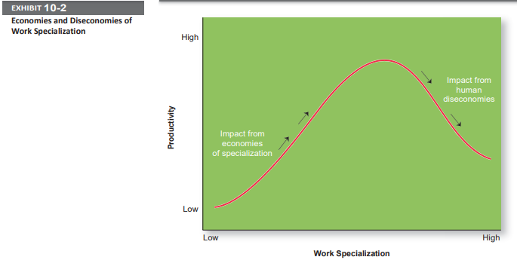

**Departmentalization:** After deciding what job tasks will be done by whom, common work activities need to be grouped back together so work gets done in a coordinated and integrated way. How jobs are grouped together is called departmentalization. Five common forms of departmentalization are used, although an organization may develop its own unique classification. (For instance, a hotel might have departments such as front desk operations, sales and catering, housekeeping and laundry, and maintenance.) Exhibit 10-3 illustrates each type of departmentalization as well as the advantages and disadvantages of each.

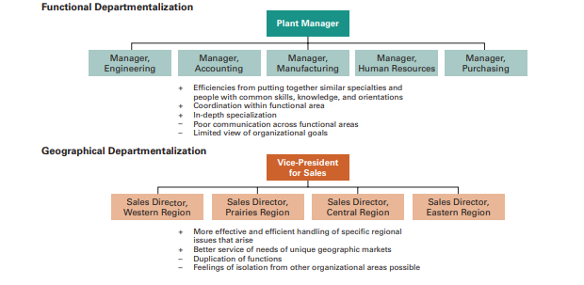

Most large organizations continue to use combinations of most or all of these types of departmentalization. For example, a major Japanese electronics firm organizes its divisions along functional lines, its manufacturing units around processes, its sales units around seven geographic regions, and its sales regions into four customer groupings. Black & Decker organizes its divisions along functional lines, its manufacturing units around processes, its sales around geographic regions, and its sales regions around customer groupings.

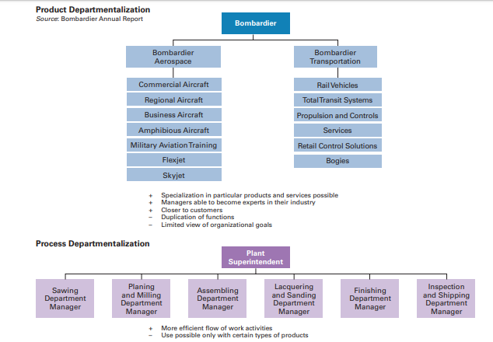

One popular departmentalization trend is the increasing use of customer departmentalization. Because getting and keeping customers is essential for success, this approach works well because it emphasizes monitoring and responding to changes in customers’ needs. Another popular trend is the use of teams, especially as work tasks have become more complex and diverse skills are needed to accomplish those tasks. One specific type of team that more organizations are using is a cross-functional team, which is a work team composed of individuals from various functional specialties. For instance, at Ford’s material planning and logistics division, a cross-functional team of employees from the company’s finance, purchasing, engineering, and quality control areas, along with representatives from outside logistics suppliers, has developed several work improvement ideas.

**Chain of command**

 People need to know who their boss is. That’s what the chain of command is all about. The chain of command is the line of authority extending from upper organizational levels to lower levels, which clarifies who reports to whom. Managers need to consider it when organizing work because it helps employees with questions such as “Who do I report to?” or “Who do I go to if I have a problem?” To understand the chain of command, you have to understand three other important concepts: authority, responsibility, and unity of command. Let’s look first at authority. There are three important concepts attached to this theory:

* Authority: Authority was a major concept discussed by the early management writers; they viewed it as the glue that held an organization together. Authority refers to the rights inherent in a managerial position to tell people what to do and to expect them to do it.8 Managers in the chain of command had authority to do their job of coordinating and overseeing the work of others. Authority could be delegated downward to lower-level managers, giving them certain rights while also prescribing certain limits within which to operate. These writers emphasized that authority was related to one’s position within an organization and had nothing to do with the personal characteristics of an individual manager. They assumed that the rights and power inherent in one’s formal organizational position were the sole source of influence and that if an order was given, it would be obeyed. Chester Barnard, proposed another perspective on authority. This view, called the acceptance theory of authority, says that authority comes from the willingness of subordinates to accept it. If an employee didn’t accept a manager’s order, there was no authority. Barnard contended that subordinates will accept orders only if the following conditions are satisfied:

1. They understand the order.

2. They feel the order is consistent with the organization’s purpose.

3. The order does not conflict with their personal beliefs.

4. They are able to perform the task as directed.

Line authority entitles a manager to direct the work of an employee. It is the employer–employee authority relationship that extends from the top of the organization to the lowest echelon, according to the chain of command, as shown in Exhibit 10.4. As organizations get larger and more complex, line managers find that they do not have the time, expertise, or resources to get their jobs done effectively. In response, they create staff authority functions to support, assist, advise, and generally reduce some of their informational burdens. For instance, a hospital administrator who cannot effectively handle the purchasing of all the supplies the hospital needs creates a purchasing department, which is a staff function. Of course, the head of the purchasing department has line authority over the purchasing agents who work for him. The hospital administrator might also find that she is overburdened and needs an assistant, a position that would be classified as a staff position. Exhibit 10-5 illustrates line and staff authority.

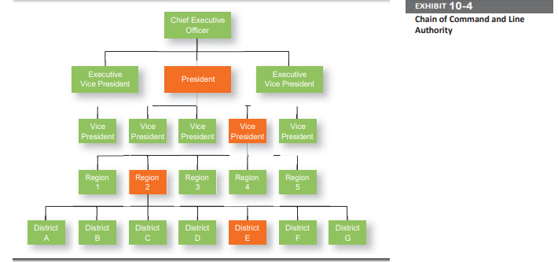

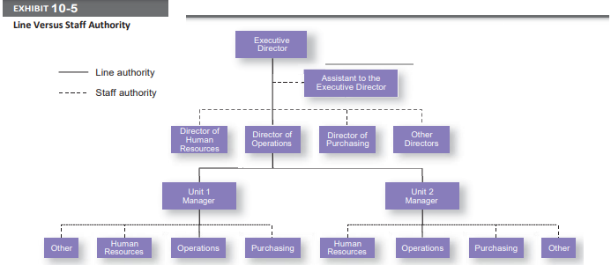

* Responsibility: When managers use their authority to assign work to employees, those employees take on an obligation to perform those assigned duties. This obligation or expectation to perform is known as responsibility. And employees should be held accountable for their performance! Assigning work authority without responsibility and accountability can create opportunities for abuse. Likewise, no one should be held responsible or accountable for work tasks over which he or she has no authority to complete those tasks.
* Unity of command: Finally, the unity of command principle (one of Fayol’s 14 management principles) states that a person should report to only one manager. Without unity of command, conflicting demands from multiple bosses may create problems as it did for Damian Birkel, a merchandising manager in the Fuller Brands division of CPAC, Inc. He found himself reporting to two bosses—one in charge of the department-store business and the other in charge of discount chains. Birkel tried to minimize the conflict by making a combined to-do list that he would update and change as work tasks changed
* **Span of Control**

How many employees can a manager efficiently and effectively manage? That’s what span of control is all about. The traditional view was that managers could not—and should not— directly supervise more than five or six subordinates. Determining the span of control is important because to a large degree, it determines the number of levels and managers in an organization—an important consideration in how efficient an organization will be. All other things being equal, the wider or larger the span, the more efficient an organization is. Here’s why. Assume two organizations, both of which have approximately 4,100 employees. As Exhibit 10-6 shows, if one organization has a span of four and the other a span of eight, the organization with the wider span will have two fewer levels and approximately 800 fewer managers. At an average manager’s salary of $42,000 a year, the organization with the wider span would save over $33 million a year! Obviously, wider spans are more efficient in terms of cost. However, at some point, wider spans may reduce effectiveness if employee performance worsens because managers no longer have the time to lead effectively.

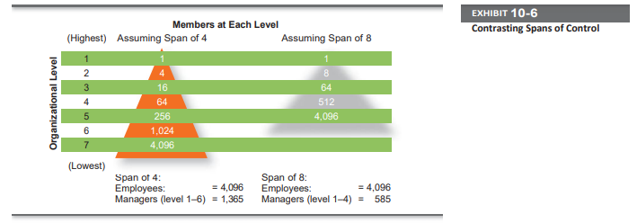

**Today’s View**: The contemporary view of span of control recognizes that many factors influence the appropriate number of employees a manager can efficiently and effectively manage. These factors include the skills and abilities of the manager and the employees, and the characteristics of the work being done. **For example,** the more training and experience employees have, the less direct supervision they need. Therefore, managers with well-trained and experienced employees can function quite well with a wider span. Other contingency variables that determine the appropriate span include similarity of employee tasks, the complexity of those tasks, the physical proximity of subordinates, the degree to which standardized procedures are in place, the sophistication of the organization’s information system,the strength of the organization’s culture, and the preferred style of the manager.7 Wider spans of control are also possible due to technology—it is easier for managers and their subordinates to communicate with each other, and there is often more information readily available to help employees perform their jobs.

**Centralization and decentralization:** One of the questions that needs to be answered when organizing is “At what organizational level are decisions made?” Centralization is the degree to which decision making takes place at upper levels of the organization. If top managers make key decisions with little input from below, then the organization is more centralized. On the other hand, the more that lower-level employees provide input or actually make decisions, the more decentralization there is. Keep in mind that centralization-decentralization is not an either-or concept. The decision is relative, not absolute—that is, an organization is never completely centralized or decentralized. Early management writers proposed that the degree of centralization in an organization depended on the situation. Their goal was the optimum and efficient use of employees. Traditional organizations were structured in a pyramid, with power and authority concentrated near the top of the organization. Given this structure, historically centralized decisions were the most prominent, but organizations today have become more complex and responsive to dynamic changes in their environments. As such, many managers believe that decisions need to be made by those individuals closest to the problems, regardless of their organizational level. In fact, the trend over the past several decades—at least in U.S. and Canadian organizations— has been a movement toward more decentralization in organizations. Exhibit 10-7 lists some of the factors that affect an organization’s use of centralization or decentralization.

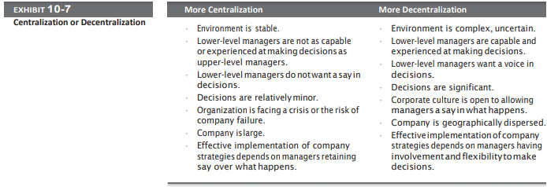

As organizations have become more flexible and responsive to environmental trends, there’s been a distinct shift toward decentralized decision making. This trend, also known as employee empowerment, gives employees more authority (power) to make decisions.

**Formalization:** Formalization refers to how standardized an organization’s jobs are and the extent to which employee behavior is guided by rules and procedures. In highly formalized organizations, there are explicit job descriptions, numerous organizational rules, and clearly defined procedures covering work processes. Employees have little discretion over what’s done, when it’s done, and how it’s done. However, where formalization is low, employees have more discretion in how they do their work. TODAY’S VIEW. Although some formalization is necessary for consistency and control, many organizations today rely less on strict rules and standardization to guide and regulate employee behavior. For instance, consider the following situation: A customer comes into a branch of a large national drug store and drops off a role of film for same-day developing minutes after the store policy cut-off time. Although the sales clerk know she’s supposed to follow rules, he also know she could get the film developed with no problem and wants to accommodate the customer. So he accepts the film, violating policy, hoping that his manager won’t find out.22 Has this employee done something wrong? He did “break” the rule. But by “breaking” the rule, he actually brought in revenue and provided good customer service. Considering there are numerous situations where rules may be too restrictive, many organizations have allowed employees some latitude, giving them sufficient autonomy to make those decisions that they feel are best under the circumstances. It doesn’t mean throwing out all organizational rules because there will be rules that are important for employees to follow—and these rules should be explained so employees understand why it’s important to adhere to them. But for other rules, employees may be given some leeway.

**Mechanistic & Organic Structures:**

Stocking extra swimsuits in retail stores near water parks seems to make sense, right? And if size 11 women’s shoes have been big sellers in Chicago, then stocking more size 11s seems to be a no-brainer. After suffering through 16 months of declining same-store sales, Macy’s CEO Terry Lundgren decided it was time to restructure the organization to make sure that these types of smart retail decisions are made.25 He’s making the company both more centralized and more locally focused. Although that may seem a contradiction, the redesign seems to be working. Lundgren centralized Macy’s purchasing, planning, and marketing operations from seven regional offices to one office at headquarters in New York. He also replaced regional merchandise managers with more local managers— each responsible for a dozen stores—who spend more time figuring out what’s selling.

Designing (or redesigning) an organizational structure that works is important. Basic organizational design revolves around two organizational forms that are described in Exhibit 10-8.26.

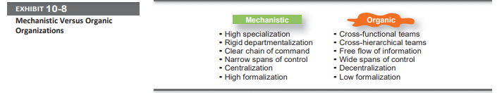

The mechanistic organization (or bureaucracy) was the natural result of combining the six elements of structure. Adhering to the chain-of-command principle ensured the existence of a formal hierarchy of authority, with each person controlled and supervised by one superior. Keeping the span of control small at increasingly higher levels in the organization created tall, impersonal structures. As the distance between the top and the bottom of the organization expanded, top management would increasingly impose rules and regulations. Because top managers couldn’t control lower-level activities through direct observation and ensure the use of standard practices, they substituted rules and regulations. The early management writers’ belief in a high degree of work specialization created jobs that were simple, routine, and standardized. Further specialization through the use of departmentalization increased impersonality and the need for multiple layers of management to coordinate the specialized departments.

The **organic organization** is a highly adaptive form that is as loose and flexible as the mechanistic organization is rigid and stable. Rather than having standardized jobs and regulations, the organic organization’s loose structure allows it to change rapidly as required.27 It has division of labor, but the jobs people do are not standardized. Employees tend to be professionals who are technically proficient and trained to handle diverse problems. They need few formal rules and little direct supervision because their training has instilled in them standards of professional conduct. For instance, a petroleum engineer doesn’t need to follow specific procedures on how to locate oil sources miles offshore. The engineer can solve most problems alone or after conferring with colleagues. Professional standards guide his or her behavior. The organic organization is low in centralization so that the professional can respond quickly to problems and because top-level managers cannot be expected to possess the expertise to make necessary decisions.